Open Solicitation

Florida High Tech Corridor Council
Industry Matching Research Program

Office of the Vice President for Research & Commercialization

Due Date: No deadline

This program will remain open until the maximum commitment level is reached.

I. PROGRAM DESCRIPTION:
Proposals are sought for partnership projects between University of Central Florida (UCF) faculty and regional high technology industries along the Florida High Tech Corridor. The primary goal of the Florida High Tech Corridor Council (FHTCC) is to attract, grow, and retain high technology companies in the Florida High Tech Corridor area.
This program is specifically designed to increase opportunities for UCF students to gain valuable hands-on industrial research experience and to expand the research activities of an FHTCC industry partner by providing matching funds to leverage research collaborations between Industry and the UCF.
Approximately $2,000,000 has been designated for the two program areas of the Florida High Tech Corridor Council matching funds program for the current year. An estimated $1.5M will be allocated to the open solicitation and an estimated $500K is allocated for the SBIR/STTR Phase II Industry External Investment program. The programs require an industry match of $3 cash for every $1 of FHTCC commitment. After the 3:1 cash match, additional in-kind support from industry is encouraged. There is no application deadline for these funds—they will be reviewed on a first-come, first-serve basis until they are exhausted.
While projects may be proposed in any discipline, applications are particularly encouraged in areas contributing to the development of the high technology sectors encompassed within the Florida High Tech Corridor Initiative. The list below directly reflects the interest and goals of the Florida High Tech Corridor Council and the map illustrates the applicable Florida counties:
●Aerospace ●Nanotechnology
●Biotechnology ●Optic and Lasers
●Information Technologies and Services ●Renewable Energy
●Manufacturing Design ●Software Development
●Marine Technologies ●Simulation and Training
●Medical Products ●Solar Technology
●Medical Technologies ●Telecommunications
●Microelectronics ●Transportation Systems

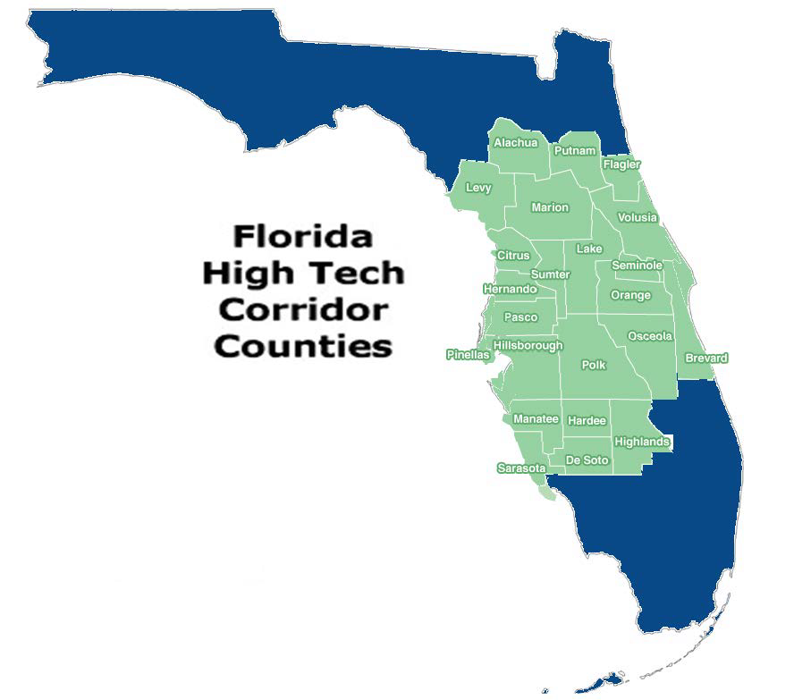

II. AWARD INFORMATION:
Award sizes are anticipated to range from $20K to $100K with an estimated total of ~$1.5M allocated to this program. Awards are contingent upon the availability of funding.

III. PROPOSAL PREPARATION AND SUBMISSION INSTRUCTIONS:

A. Proposal Preparation Instructions
(Please read the entire guidelines before beginning the proposal preparation process)
1. Select an industry partner and discuss your project with them. Obtain a signed written commitment from the industry partner for both cash and in-kind funding.
2. Prepare your proposal, which will cover the entire project (industry partner match and FHTCC funds). It is anticipated that one statement of work will suffice; however, separate budget columns are required for each source of funding. Please be advised that there is a required cash match commitment from the industry partner to qualify for this FHTCC award. The program requires an industry match of $3 cash for every $1 of FHTCC commitment. After the 3:1 cash match, additional in-kind support from industry is encouraged. Please review Section III.B.1.a of this solicitation for the specific guidance concerning funding requirements.
3. Faculty and the industry partner operations staff are strongly encouraged to discuss the proposal with their respective legal/contracting offices prior to submitting the proposal to reduce the time from award to execution of the project.
4. Submit the completed proposal to your assigned Proposal Manager in the Office of Research & Commercialization. A list of assigned Proposal Managers is available at http://www.research.ucf.edu/Research/Administrators.html.

B. Budgetary Information
1. FHTCC funding is awarded only if industry funding has actually been received.
a. Funds requested under this program will provide cash match based on the level of industry cash commitment. The required ratio of industry cash match is 3:1 (Industry Partner: FHTCC). For example, if the total FHTCC Industry Matching Research Program request is $50,000 cash, required the industry partner match would be $150,000 cash.

(3:1 Match Ratio)
Funding Source | Amount
FHTCC: | $50,000
Industry cash: | $150,000
Total project costs: | $200,000
After the 3:1 cash match, additional in-kind support from industry is encouraged. In-kind support may include staff time spent on the project, equipment usage, or lab usage. This should be documented through a signed letter of commitment or in the case of an award, the award document.
As always, an additional cash match may be substituted for in-kind support if the company can show an equivalent level of commitment to the project that the in-kind support demonstrates.
2. All funding commitments must be listed on the FHTCC proposal budget and on the FHTCC industry partner’s signed letter of commitment. (A representative authorized to commit funding should sign this commitment letter)

C. Deadline Dates
There is no application deadline for this solicitation. Proposals will be reviewed on a first come, first serve basis each year and awards for eligible proposals with exceptional quality will be granted until funds are exhausted.

D. Proposal Application Format
(You can access the entire RFP including forms by clicking on MS Word or PDF. The excel budget can be accessed by clicking on the budget link)
1. UCF Proposal Transmittal Form:
a. Complete the online UCF Proposal Transmittal Form (PTF) electronically through “My Research” and then please notify your Proposal Manager. Please note that when completing the online entry, select College/Department under the “Sponsoring Organization,” scroll down to the Office of Research & Commercialization, then click the plus symbol (+), then click “UCF/I-4.”
OR
b. Complete the hard copy UCF Proposal Transmittal Form (PTF) electronically (please notify your Proposal Manager) with required signatures and cost share/matching as indicated. Please write “UCF/I-4” for the agency name.
2. Cover Page: Complete cover page.
3. Technical Description: Maximum of 5 pages, single spaced, 12-point type and one-inch margins on top, bottom, left and right. Include a three-sentence layman’s abstract that will be published if your project is awarded.
4. References (Optional): You may include one additional page for references.
5. Budget: The use of this budget template is not mandatory. However, if you use your own budget format please include Industry, FHTCC, and Total budget columns. Facilities & Administrative costs (formerly indirect costs) are not applicable to the FHTCC matching portion but must be included as a part of the industry partner portion unless an F&A Rate Reduction Request is granted (if applicable). Please download the current Fringe Benefit rates and F&A (formerly indirect cost) rates. Please include a list of the in-kind match from the FHTCC industry partner on the bottom of the budget for evaluation purposes.
6. Industry Commitment: Include evidence of commitments from high tech corridor partners. A letter on company letterhead signed by an authorized representative of the company listing the project title, amount, and type of support (i.e., cash and in-kind) is required.
7. Resume: Include a resume of no more than two pages for the PI or Project Director and any Co-Principal Investigators. You may use the attached format or your own format.
8. Publications: Submit a copy of the title pages of the two most recent refereed publications dealing with the proposed research.
9. Evaluation Sheet: Complete only the first three lines of the Evaluation Sheet.
Please be advised that if the page limitation is exceeded or any component listed above is excluded, your proposal may be returned without review. This requirement is in place to ensure equity among proposals.

IV. MERIT REVIEW CRITERIA:
A. A committee consisting of the President, Provost, Vice-President for Research, and a sub- committee of the Florida High-Tech Corridor Council or their designees will evaluate each proposal.

B. Criteria for selection of awards (in order of priority) include:
1. The Evaluation Committee’s rating of the proposal’s technical merit.
2. Support of the goal of the Florida High Tech Corridor Council program to attract, grow and retain technology-based industry in our region.
3. Amount of required cash and in-kind match that has been provided.
(Please see Section III.B.1.a of this solicitation for specific cost share requirements)
4. Strength of partnerships (joint projects with the University of South
Florida and the University of Florida are encouraged).
5. Student involvement in the proposed research. Industry funds should include
tuition for students involved, but is not required.

Multi-year proposals will be considered. Funding beyond year 1 is not guaranteed and will be based on progress made during the current year, as well as, the amount of industry funds obtained, the technical merit of the work proposed for the second year, and the Principal Investigator (PI) qualifications.

V. AWARD ADMINISTRATION INFORMATION:
A. Each College, Institute, and Center has an assigned Contract Manager or Contract Administrator. The Contract Manager or Contract Administrator assigned to your area is listed at http://www.research.ucf.edu/Research/Administrators.html
B. The industry contracts should be executed within 4 months of award notice. Failure to do so could result in the cancellation or reallocation of FHTCC funds to other projects. Also, if the industry partner reduces its award amount, then the FHTCC amount would also be reduced proportionately. Please contact your Contract Manager if changes are required. For reporting purposes, a letter validating in-kind industry support will be requested at the end of the project.

Submission:
You are encouraged to submit your application on-line through “My Research” located on the ORC website. Please notify your Proposal Manager when submitting electronically. If you cannot submit online, then please provide a completed hard copy version to your assigned Proposal Manager in the Office of Research & Commercialization. The sponsoring agency on the Proposal Transmittal Form (PTF) should be addressed to:

Dr. Thomas O’Neal, Associate Vice President for Research
Office of Research & Commercialization
12201 Research Parkway, Suite 501
Orlando, FL 32826-3246
Office: 407-823-3778

University of Central Florida
Office of the Vice President for Research

FHTCC Industry Matching Research Program
Open Solicitation Application Forms:

COVER PAGE

Principal Investigator Department Co-Principal Investigator Department Co-Principal Investigator Department Chair Dean

Title of Proposal

Industry Partner (company name, point of contract and address)

Phone Fax E-Mail

Total Requested Funding (Cash amounts only): Please do not list in-kind on this section.

FHTCC Request Industry Partner Funding Total Effort for Match

+ =

FHTCC Industry Matching Research Program
Open Solicitation

RESUME FOR PRINCIPAL INVESTIGATOR

1. | Name
2. | Department/College/ Center/Institute
3. | Phone
4. | Title of Proposal

5. Current Academic Rank 6. Years at UCF

7. Degrees Earned Field Institution Year

For questions 8 and 9, use remainder of this page and no more than one additional page with PI's name on the header.
8. Publications Summary (Please list 5 most relevant publications)

9. Research and related experience (Please summarize work experience and research experience, including employer, title, inclusive of appointment, and external funding received at UCF or elsewhere as PI or Co-Pl, including consulting and patient activities.)

FHTCC Industry Matching Research Program
Open Solicitation

EVALUATION SHEET

1. Name

2. Department/College/

Center/Institute

3. Title of Proposal

Circle the application rating:

Weak Acceptable Strong Excellent

I. Technical Merit

II Meets FHTCC goals

III. Specificity and Credibility of Funding Sources

IV. Strength of
Partnership

V. Student Involvement

Comments:
1 2 3 4 5 6 7

1 2 3 4 5 6 7

1 2 3 4 5 6 7

1 2 3 4 5 6 7

1 2 3 4 5 6 7

TOTAL

FHTCC Industry Matching Research Program
Open Solicitation

BUDGET

Click here for the Excel budget template.

FHTCC Industry Matching Research Program
Open Solicitation

FINAL TECHNICAL REPORT (page 1 of 2)

- Recipient name: University of Central Florida Award Amount:

- Principal Investigator:

- Co-Principal Investigator(s) (if applicable):

- Agency’s Project Number: UCF Project Number:

- Project Title:
- Award Dates (including any granted no-cost extensions):

  - Start Date: End Date:

- Brief description of project objectives:

- Were these objectives accomplished as scheduled?

- If objectives were not accomplished, please provide reason(s):

- Detail the most relevant activities of the project:

FHTCC Industry Matching Research Program
Open Solicitation

FINAL TECHNICAL REPORT (page 2 of 2)

- Describe project findings. Are these consistent with anticipated findings?

- Detail any publication(s) resulting from this project:

- Describe any other specific products and contributions of the project:

- List general conclusions (use additional pages as needed):

